PHYSICAL EDUCATION STUDIES

**YEAR 11 GENERAL**

**Functional Anatomy**

**2019**

**Question/Answer Booklet**

Name: ____________________________________

**Task weighting: 8%**

***Time allowed for this paper***

Reading/planning time before commencing work: Five minutes

Working time for paper: Fifty minutes

|  |  |
| --- | --- |
| ***Material required/recommended for this paper***  **To be provided by the supervisor**  This Question/Answer booklet  Sections One and Two: Write your answers in this Question/Answer booklet.  Spare lined paper  **To be provided by the candidate**  Standard items:Pens, pencil, eraser, correction fluid, highlighter, ruler |  |

***Important note to candidates***

No other items may be taken into the examination room. It is **your** responsibility to ensure that you do not have any unauthorised notes or other items of a non-personal nature in the examination room. If you have any unauthorised material with you, hand it to the supervisor **before** reading any further. All electronic devices are **NOT** permitted to be used unless arranged prior with the teacher. Students caught using electronic devices will automatically be given zero marks for the test.

***Structure of this paper***

|  |  |  |  |  |
| --- | --- | --- | --- | --- |
| Section | Number of questions available | Number of questions to be attempted | Suggested working time  (minutes) | Marks available |
| Section One:  Short Answer | 15 | 15 | 40 | 36 |
| Section Two:  Extended Answer | 1 | 1 | 10 | 9 |
|  |  |  | Total Marks | 45 |

**Instructions to candidates**

1. The rules for the conduct of this exam have been outlined. Sitting this examination implies that you agree to abide by these rules.

2. Answer all questions according to the following instructions.

3. You must be careful to confine your responses to the specific questions asked and to follow any instructions that are specific to a particular question.

4. Spare pages are included at the end of this booklet. They can be used for planning your responses and/or as additional space if required to continue an answer.

* Planning: If you use the spare pages for planning, indicate this clearly at the top of the page.
* Continuing an answer: if you need to use the space to continue an answer, indicate in the original answer space where the answer is continued, i.e. give the page number. Fill in the number of the question(s) that you are continuing to answer at the top of the page

**Section One: Short Answer (36 marks)**

1. Describe two (2) functions for the circulatory system (2 Marks)

|  |  |
| --- | --- |
| **Description** | **Marks** |
| One mark for each response - Choose 2 out of the 4  1. Circulate blood to body  2. Transport of nutrients   * Transport O2, water and nutrients to cells in the blood * Transport CO2 and wastes away from the cells   3. Regulation of body’s temperature (thermoregulation)  4. Immunity: White blood cells fight infection | 2 |
| **Total** | **/2** |

1. Identify the three (3) structures labeled below on the heart. (3 Marks)

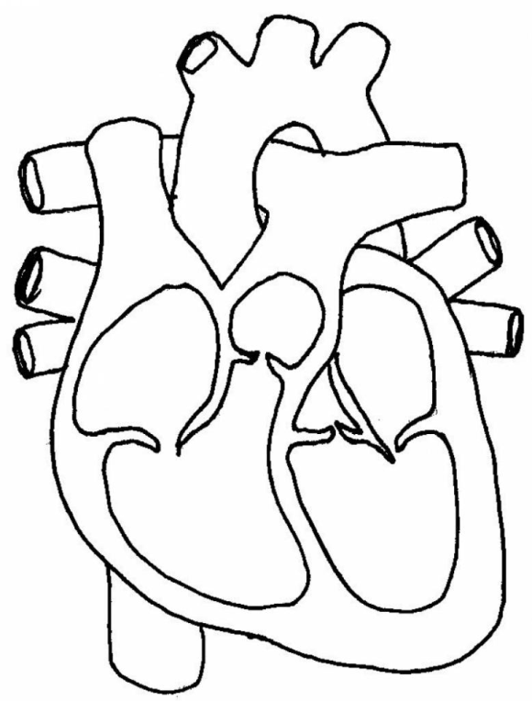

|  |  |
| --- | --- |
| **Description** | **Marks** |
| Aorta  Pulmonary Vein  Left Ventricle | 3 |
| **Total** | **/3** |

1. Identify the name of each anatomical plane described below:
2. The plane that divides the body into a left and right section

____________________________

1. The plane that divides the body into a top and bottom section

__________________________

1. The plane that divides the body into a front and back section

___________________________

(3 marks)

|  |  |
| --- | --- |
| **Description** | **Marks** |
| One mark for each response   1. sagittal plane 2. transverse plane 3. frontal plane | 1–3 |
| **Total** | **/3** |

1. Identify structures four (4), eight (8) and eleven (11) labeled below on the respiratory system.

(3 Marks)

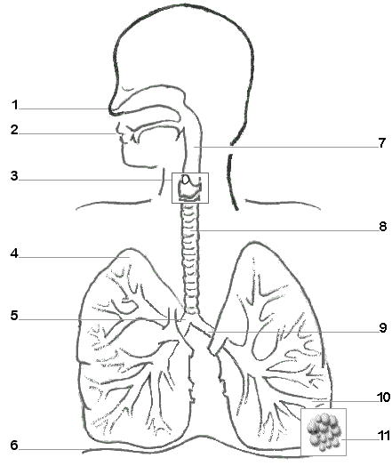

|  |  |
| --- | --- |
| **Description** | **Marks** |
| Lung  Trachea  Alveoli | 3 |
| **Total** | **/3** |

1. Describe two (2) functions for the respiratory system (2 Marks)

|  |  |
| --- | --- |
| **Description** | **Marks** |
| One mark for each response - Choose 2 out of the 4   1. Deliver oxygen from the atmosphere to the lungs. 2. Provide method of gaseous exchange within the lungs.    * + Oxygen enters the blood, carbon dioxide exits. 3. Create speech as air passes over the vocal cords. 4. Facilitate sense of smell. | 2 |
| **Total** | **/2** |

1. Choose two structures from the image above and briefly explain its function (4 marks)

|  |  |
| --- | --- |
| **Description** | **Marks** |
| One mark for each response - Choose 2 out of the 7  One mark for the brief explanation each  Nasal cavity & Mouth; Pharynx; Larynx; Trachea; Bronchi; Bronchioles; Alveoli  Example:  **Nasal cavity & mouth**   * + - Where the air enters the respiratory system |  |
| **Total** | **/4** |

1. Describe two (2) functions of the skeletal system (2 Marks)

|  |  |
| --- | --- |
| **Description** | **Marks** |
| One mark for each response - Choose 2 out of the 5   1. Provides a **framework** for the body and gives its shape. 2. Provides **support** and a solid attachment or anchor point for muscles, and so allows bones to act as levers to produce movement. Muscles are connected to bones by tendons and bones are connected to each other by ligaments. 3. Individual bones **protect** various vital organs in the body. For example, the cranium protects the brain. 4. The bones **store** essential minerals such as calcium and phosphorus which give the bones hardness and strength. 5. The long bones contain bone marrow which **produce** red blood cells. | 2 |
| **Total** | **/2** |

1. Describe the difference between a short bone and an irregular bone. Provide an example for each. (4 marks)

|  |  |
| --- | --- |
| **Description** | **Marks** |
| Short Bones   * Are composed of a spongy type of tissue with a thin hard surface * They tend to be round in shape and allow a large range of movement at the wrist and ankle * Examples are your carpals and tarsals   Irregular bones   * Irregular bones are of varying shapes, reinforced in areas where additional strength is needed. * Examples are vertebrae and the spinal column |  |
| **Total** | **/4** |

1. Identify the three (3) structures below on the skeletal system. (3 Marks)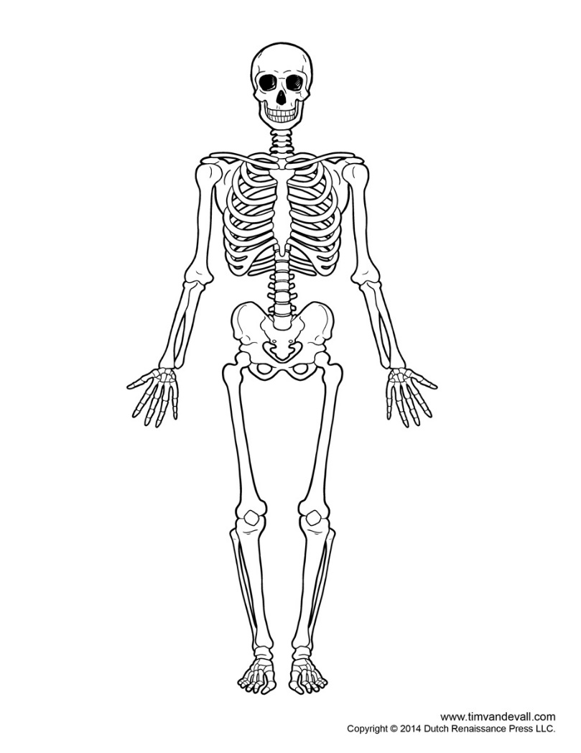

|  |  |
| --- | --- |
| **Description** | **Marks** |
| Humerous  Patella  Tibia | 3 |
| **Total** | **/3** |

1. Describe two (2) functions of the muscular system (2 Marks)

|  |  |
| --- | --- |
| **Description** | **Marks** |
| One mark for each response - Choose 2 out of the 3   * **Create movement** as skeletal muscles pull on bones and enable the body’s development of strength, endurance, speed and power. * **Maintain posture** through coordinated contraction of appropriate muscles and stabilize ligament structure across joints * **Maintain bodily functions**  including blood circulation (heart), digestion (muscles of the stomach and intestines) and breathing (diaphragm and chest muscles). |  |
| **Total** | **/2** |

1. What are the three types of muscles? (3 Marks)

|  |  |
| --- | --- |
| **Description** | **Marks** |
| 1. Skeletal 2. Smooth 3. Cardiac |  |
| **Total** | **/3** |

1. Identify the three (3) structures below on the muscular system. (3 Marks)

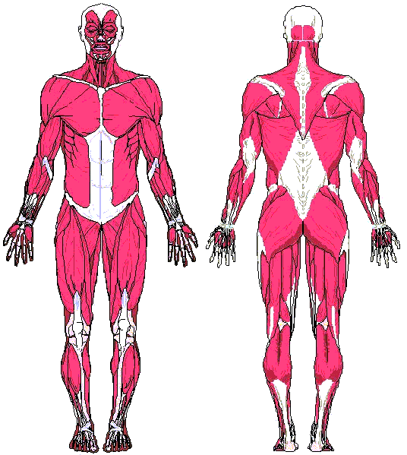

|  |  |
| --- | --- |
| **Description** | **Marks** |
| Bicep  Quadriceps  Gluteus maximus | 3 |
| **Total** | **/3** |

1. Explain the difference between flexion of the arm and extension of the arm. (2 Marks)

|  |  |
| --- | --- |
| **Description** | **Marks** |
| One mark each for:   * flexion – closes the angle between two bones; brings bones closer together * extension – increases the angle between two bones; straightening motion   or other appropriate responses. | 1–2 |
| **Total** | **/2** |

**Section Two: Extended Answer (9 marks)**

1. State the three somatotypes and describe the appearance of a person for each body type.

(9 marks)

|  |  |
| --- | --- |
| **Description** | **Marks** |
| * States each somatotype * Detailed and accurate description of each somatotype – 2 marks * Basic description of each somatotype – 1 mark  1. endomorphic – fat deposits; pear-shaped body; wide hips and shoulders 2. mesomorphic – muscular; broad shoulders; minimal fat 3. ectomorphic – minimal muscle or fat; tall and thin; narrow shoulders and hips   or other appropriate responses. | 1-9 |
| **Total** | **/9** |

**END OF TEST**

**SPARE PAGE**

________________________________________________________________________________________________________________________________________________________________________________________________________________________________________________________________________________________________________________________________________________________________________________________________________________________________________________________________________________________________________________________________________________________________________________________________________________________________________________________________________________________________________________________________________________________________________________________________________________________________________________________________________________________________________________________________________________________________________________________________________________________________________________________________________________________________________________________________________________________________________________________________________________________________________________________________________________________________________________________________________________________________________________________________________________________________________________________________________________________________________________________________________________________________________________________________________________________________________________________________________________________________________________________________________________________________________________________________________________________________________________________________________________________________________________________________________________________________________________________________________________________________________________________________________________________________________________________________________________________________________________________________________________________________________________________________________________________________________________________________________________________________________________________________________________________________________________________________________________________________________________________________________________________________